Abibitumi Black Power Conference and Abibifahodie Festival
  - December 12–14, 2025
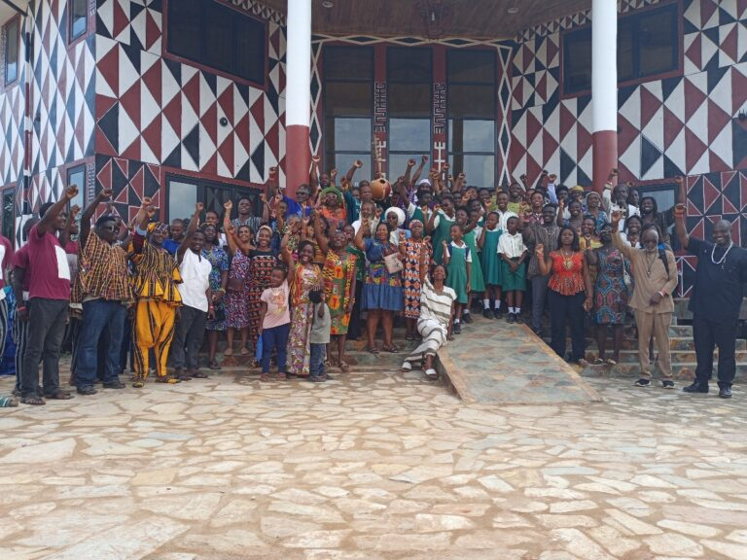

Conference Event Schedule
Time (Ghana) | Time (EST US) | Friday (Fiada) Dec 12th | Saturday (Memeneda) Dec 13th | Sunday (Kwaisada) Dec 14th
8:00–8:30am | On Ground only | Registration/Children's Area Opens | Registration/Children's Area Opens | Registration/Children's Area Opens
8:45–9:00am |  | Drum Call Grand Opening Procession (Everyone)
9:00–9:50am | 4:00–4:50am | Blacknificent Opening Ceremony/Acrobat Dancers  Honorable Samuel Okudzeto Ablakwa or Honorable Gyakye Quayson, Honorable Abla Dzifa Gomashie, Ɔbenfo Kobby Mensah, John Evans Kumordzi MCE | Opening - Morning Performance | Opening - Dinto/Naming Ceremony
10:00–10:50am | 5:00–5:50am |  | Prof Joseph Yaro/PG Michael Duncan UNIA | Nana Akosua Seɔyɔ (AAAG President)/Nana Yaw Wi Asamoah Boadi
11:00–11:50am | 6:00–6:50am | Vendor Break | Fashion Show/Vendor Break | Auction
12:00–12:50pm | 7:00–7:50am | Nana Mawiyah Kambon | Dre Taylor (Beyond Investments)/Ayana Partee | Victor Beausoleil: Malcolm X Liberation Institute/Okunini Kmt Shockley
1:00–1:50pm | 8:00–8:50am | Lunch/ Musical Performance | Lunch/ Shikwelɔi Dance and Drum Ensemble | Lunch/ Mama Wudasi's MMGF (1:20-1:30pm)
2:00–2:50pm | 9:00–9:50am | Nataki Kambon | Calvin Daniels, Cashawn/Shevon Myer | Kevoy Burton (Ghana Caribbean Association President)/Dr. Monique Swift (ABPsi)
3:00–3:50pm | 10:00–12:50am | Dinner Spoken Word | Dinner/Film Screening - NZO, AIR, What is the Black Body? | Dinner/Awards Ceremony Kofi Okyere Darko
4:00–4:50pm | 11:00–11:50am | Closing | Closing | Closing
5:00–5:50pm | 12:00–12:50pm | Closing | Closing | Closing

Contact:
Abibitumi.com
email: conference@abibitumi.com
